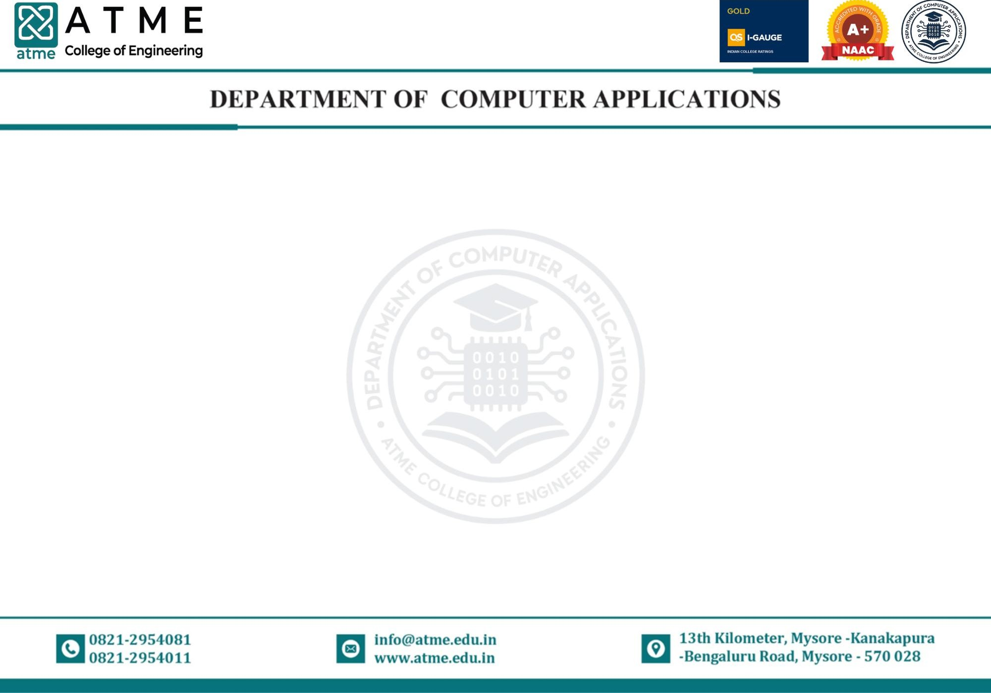

LESSON PLAN & WORK-DONE DIARY FOR AY:2025-26, EVEN SEMESTER

Course with Code: D e s i g n a n d A n a l y s i s o f A l g o r i t h m s L a b o r a t o r y – B B C A L 4 06 |  |  |  | Faculty: Mrs. Yeshashwini Bhandari K R |  |  | Semester & Section: IV Sem
Class No. | Date planned (DD/MM) | Topics to be covered | TLP Planned | Class No. | Date of Conduction (DD/MM) | Topics Covered |  | TLP  Executed | Remarks if any deviation
Program List
[1] Write a Python program that demonstrates Big-O notation by analyzing the time complexity of a simple loop.
[2] Write a Python program to implement binary search using the divide and conquer strategy.
[3] Write a Python program to find the maximum and minimum elements in an array using divide and conquer approach.
[4] Write a Python program to solve the fractional knapsack problem using a greedy strategy.
[5] Write a Python program to find the Minimum Cost Spanning Tree of a graph using Prim’s algorithm.
[6] Write a Python program to solve the Traveling Salesperson Problem (TSP) using dynamic programming.
[7] Write a Python program to find the all-pairs shortest path using Floyd-Warshall algorithm.
[8] Write a Python program to perform depth-first search on a graph.
[9] Write a Python program to solve the N-Queens problem using backtracking.
[10] Write a Python program to find all subsets that sum to a given target using backtracking (Sum of Subsets problem)

Course with Code: D e s i g n a n d A n a l y s i s o f A l g o r i t h m s L a b o r a t o r y – B B C A L 4 06 |  |  |  | Faculty: Mrs. Yeshashwini Bhandari K R |  |  | Semester & Section: IV Sem
Class No. | Date planned (DD/MM) | Topics to be covered | TLP Planned | Class No. | Date of  Conduction (DD/MM) | Topics Covered |  | TLP  Executed | Remarks if any deviation
01 |  | Program-1 | PPT |  |  |  |  | PPT
02 |  | Program-2 | PPT |  |  |  |  | PPT
03 |  | Program-3 | PPT |  |  |  |  | PPT
04 |  | Program-4 | PPT |  |  |  |  | PPT
05 |  | Program-5 | PPT |  |  |  |  | PPT
06 |  | Program-6 | PPT |  |  |  |  | PPT
07 |  | Program-7 | PPT |  |  |  |  | PPT
08 |  | Program-8 | PPT |  |  |  |  | PPT
09 |  | Program-9 | PPT |  |  |  |  | PPT
10 |  | Program-10 | PPT |  |  |  |  | PPT

 | Activity | Planned | Actual | Remarks
1 | Practical Classes | 10
2 | Assignments/Quizzes/Activity/ Self-study | 01
3 | Tutorials/ Extra classes | 01
4 | Internal Assessments | 2
5 | ICT based Teaching  (% of usage in Curriculum) | 100%
Planning |  |  | Execution
Faculty Signature: |  |  | Faculty Signature:
HoD Signature: |  |  | HoD Signature:

